EXPERIMENT 17
Simulation of V2V and V2I Latency and Packet Delivery
Aim
To simulate V2V and V2I communication using MATLAB and analyze communication latency and packet delivery ratio under different distances and channel conditions.
Procedure
- Open MATLAB and create a new script.
- Define the number of packets, packet size and transmission rate.
- Define communication distances.
- Set propagation speed, processing delay and queuing delay.
- Calculate transmission and propagation delays.
- Simulate packet delivery under two packet-loss conditions.
- Calculate received packets, lost packets and PDR.
- Plot latency and PDR against communication distance.
- Compare both scenarios.
MATLAB Program
clc;
clear;
close all;

% Input parameters
N = 1000;
packetSize = 300*8; % bits
Rb = 10e6; % 10 Mbps
c = 3e8; % Propagation speed

Tp = 1e-3; % Processing delay
Tq = 1e-3; % Queuing delay

distance = [50 100 150 200];

loss1 = 0.05;
loss2 = 0.15;

% Transmission delay
Ttx = packetSize/Rb;

% Propagation delay
Tprop = distance/c;

% Total latency
latency = (Ttx + Tprop + Tp + Tq)*1000;

% Packet delivery simulation
rng(1);

received1 = sum(rand(N,1) > loss1);
received2 = sum(rand(N,1) > loss2);

PDR1 = received1/N*100;
PDR2 = received2/N*100;

% PDR for different distances
PDR_distance1 = PDR1 - 0.02*distance;
PDR_distance2 = PDR2 - 0.03*distance;

% Display results
fprintf('Scenario 1 PDR: %.2f %%\n',PDR1);
fprintf('Scenario 2 PDR: %.2f %%\n',PDR2);

Results = table(distance',latency', ...
PDR_distance1',PDR_distance2', ...
'VariableNames',{'Distance_m','Latency_ms', ...
'Scenario1_PDR','Scenario2_PDR'});

disp(Results);

% Latency graph
figure;
plot(distance,latency,'-o','LineWidth',2);
xlabel('Distance (m)');
ylabel('Latency (ms)');
title('V2X Latency vs Distance');
grid on;

% PDR comparison
figure;
bar([PDR1 PDR2]);
set(gca,'XTickLabel',{'Scenario 1','Scenario 2'});
ylabel('Packet Delivery Ratio (%)');
title('V2X Packet Delivery Comparison');
grid on;

% PDR vs distance
figure;
plot(distance,PDR_distance1,'-o','LineWidth',2);
hold on;
plot(distance,PDR_distance2,'-s','LineWidth',2);
xlabel('Distance (m)');
ylabel('PDR (%)');
title('PDR vs Communication Distance');
legend('Scenario 1','Scenario 2');
grid on;
hold off;
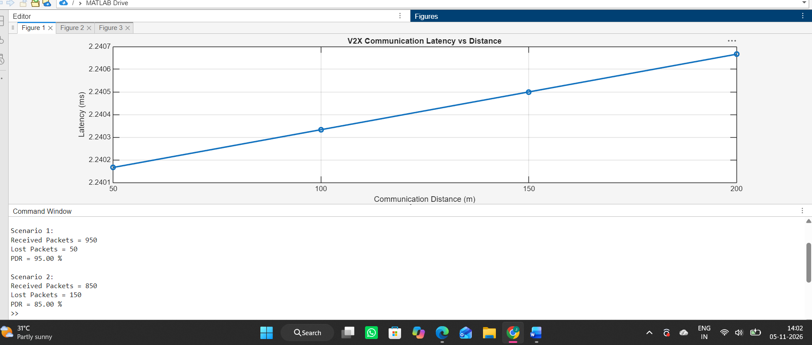

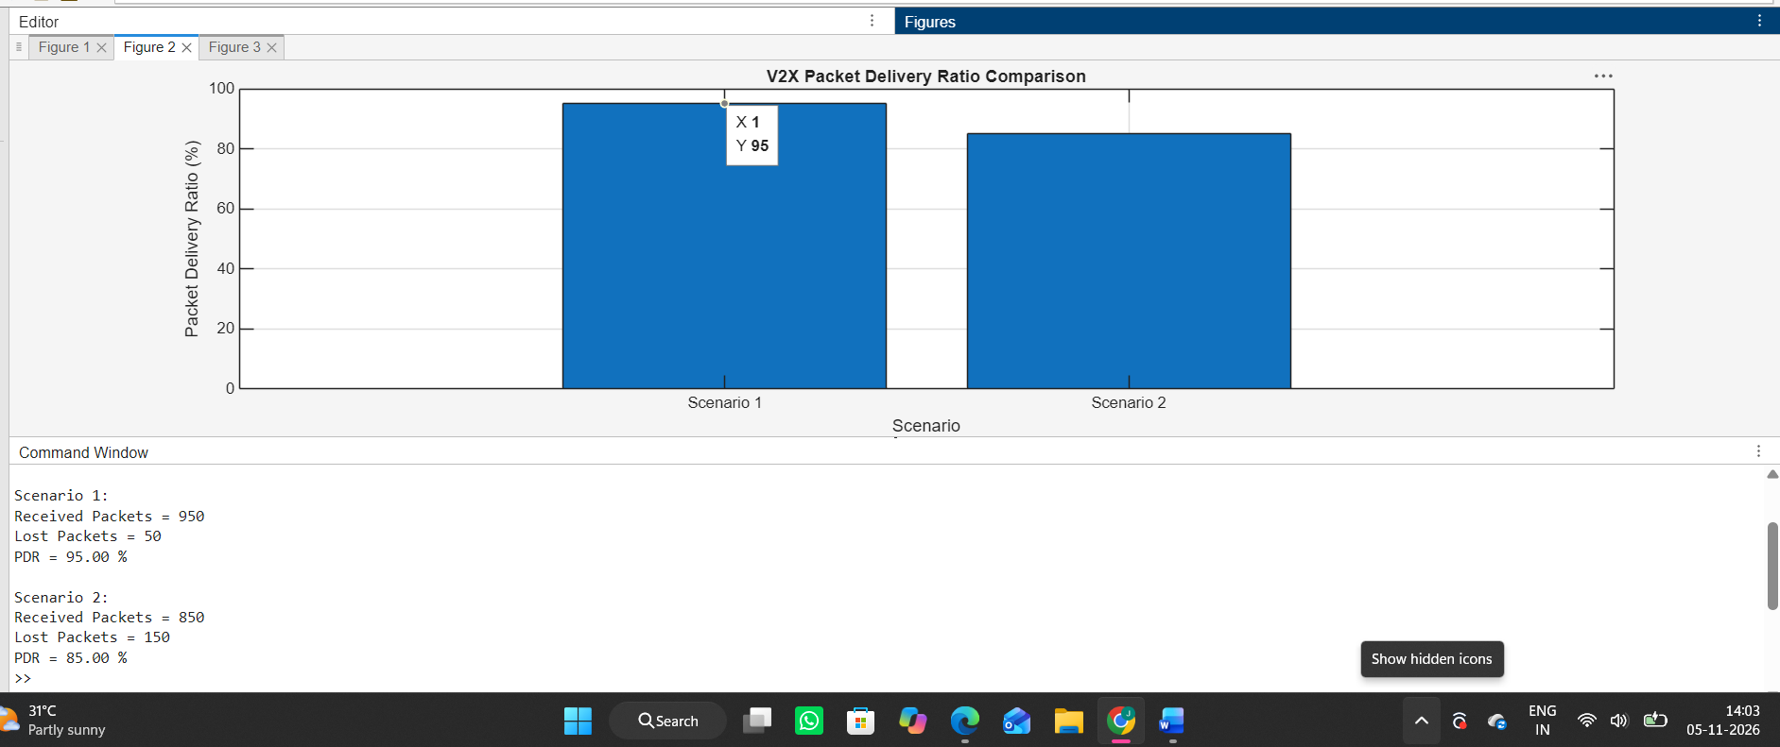

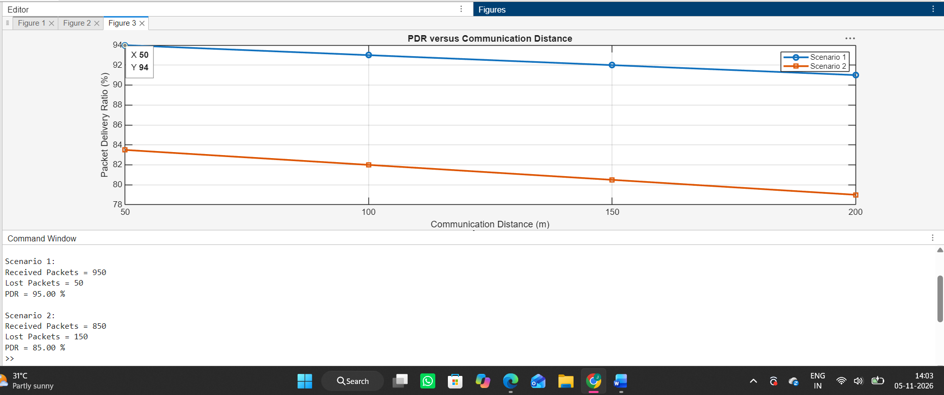

Result
The V2V and V2I communication model was successfully simulated using MATLAB. Communication latency and packet delivery ratio were calculated for different distances. The scenario with lower packet-loss probability showed better packet delivery reliability.

